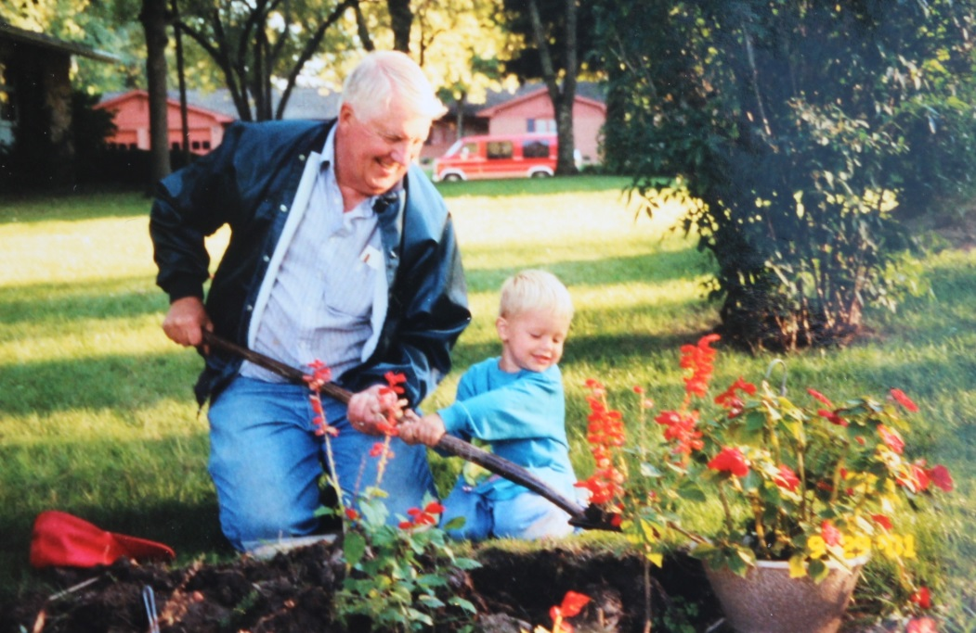

David Wolfe List and grandson, Alexander Thomas List – about 2001

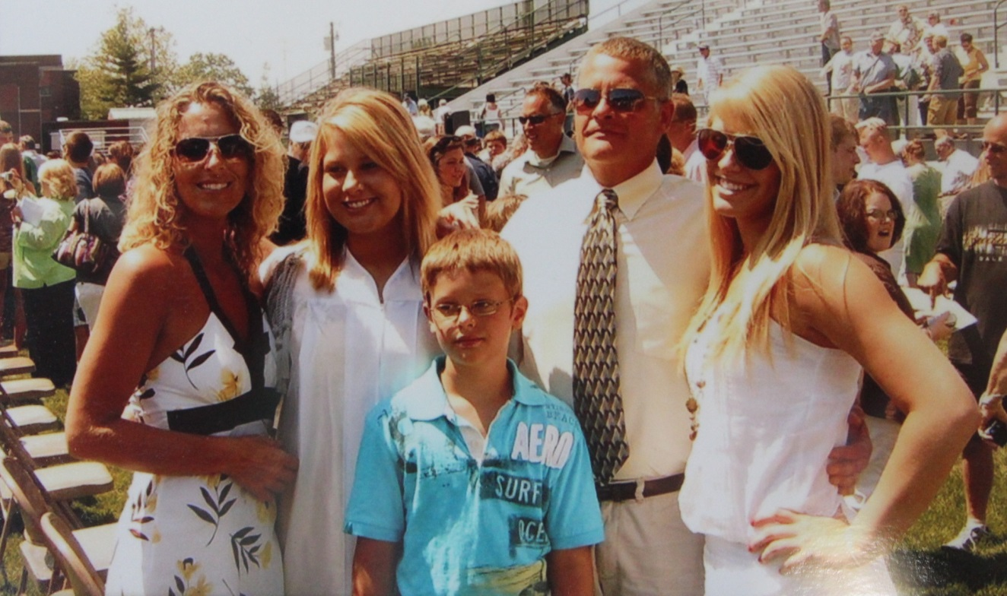

l to r: Malena Varney List, Hannah Leann List, Alexander Thomas List, Brent Allen List,

Andrea Briann List – 2010